1. 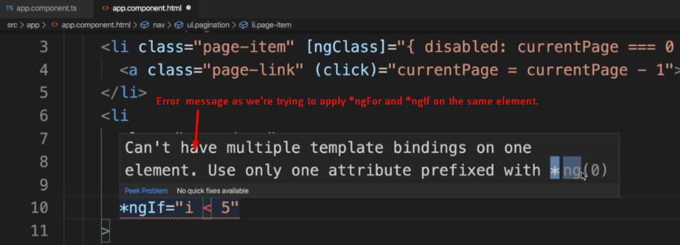
2. **NOTE**: We can apply only one structural directive on a given element.
3. **Solution 01**: Wrap the <li> in <div> and apply the *ngFor on this <div>.   
   **Example**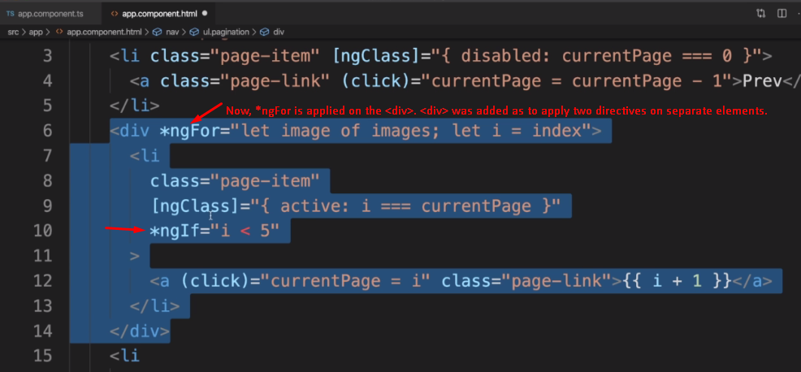:
4. 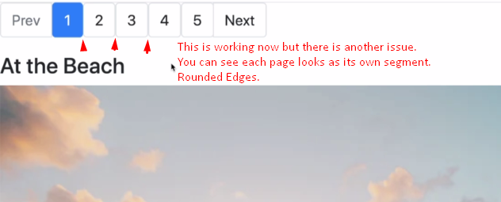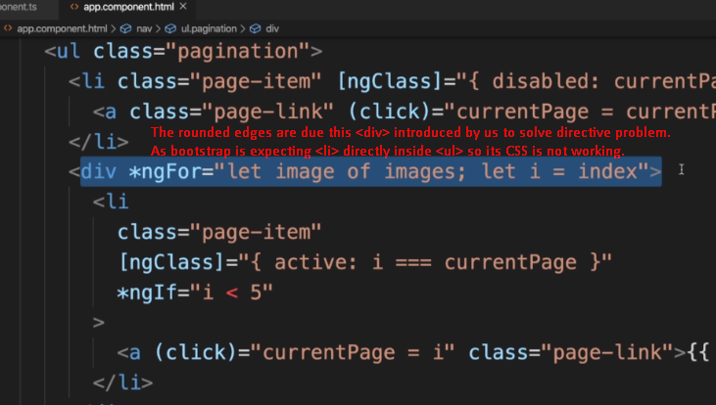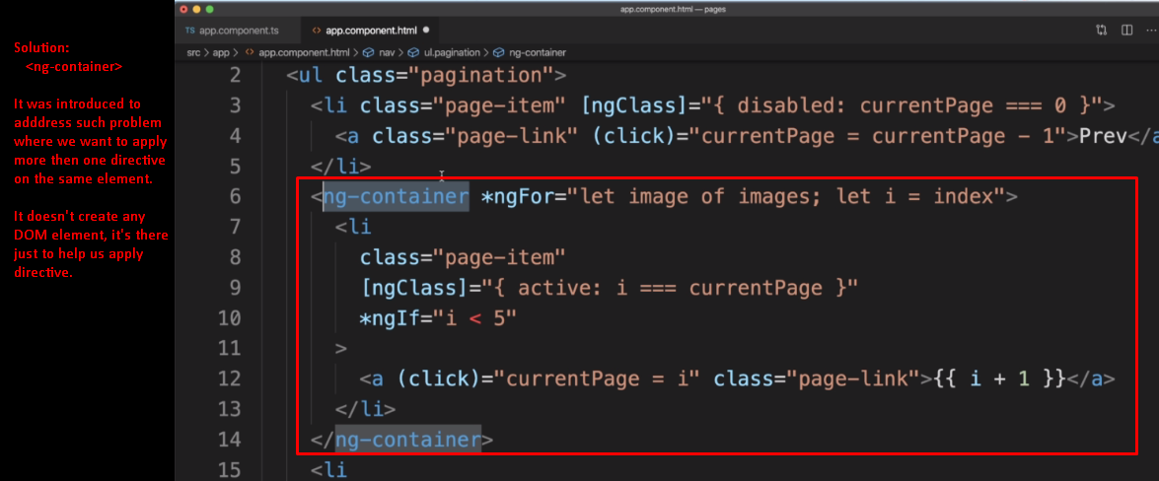
5. 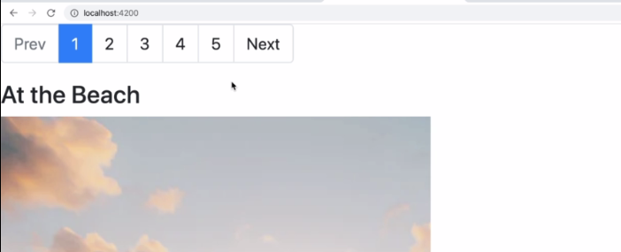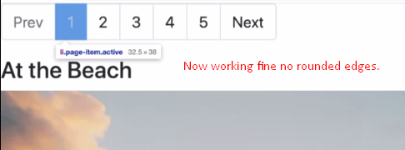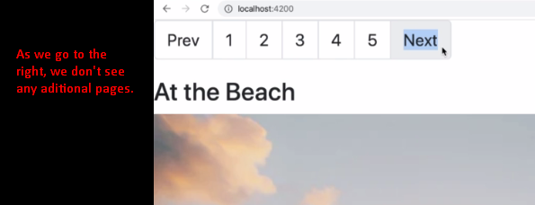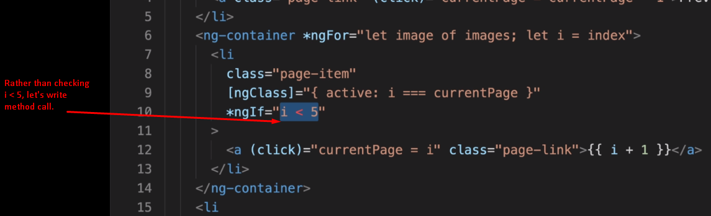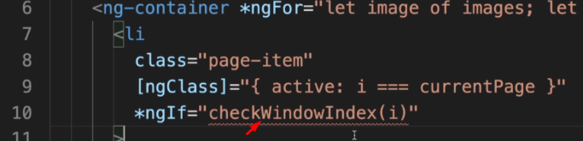
6. We will this method checkWindowIndex(i) to decide whether we have to show <li> or not. 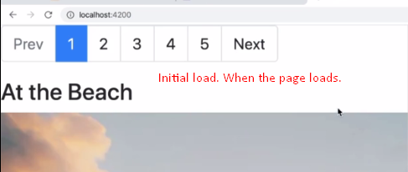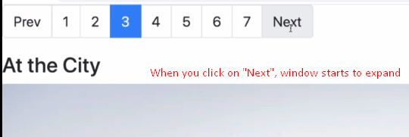  
   **NOTE**: When you click on “Next” or “Prev”, the page index expands or contract (minimum 5 pages).